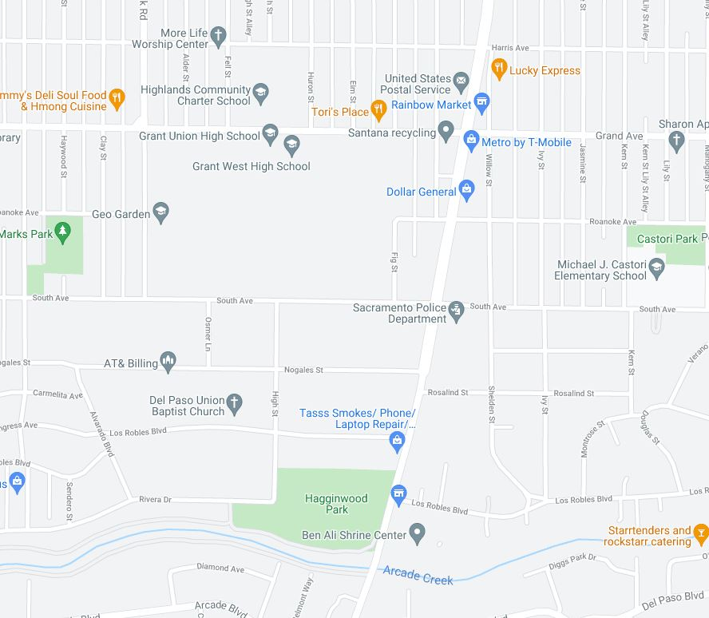

Root Cellar

Community Garden

**INSERT YOUR OWN MAP AND ROUTE HERE**

________________________________________________________________________________________________________________________________________________________________________________________________________________________________________________________________________________________________________________________________________________________________________________________________________________________________________________________________________________________________________________________________________________________________________________________________________________________________________________________________________________________________________________________________________________

________________________________________________________________________________________________________________________________________________________________________________________________

_______________________________________________________________________________________________________________________________________________________________

_______________________________________________________________________________________________________________________________________________________________

_______________________________________________________________________________________________________________________________________________________________

_______________________________________________________________________________________________________________________________________________________________

_______________________________________________________________________________________________________________________________________________________________

_______________________________________________________________________________________________________________________________________________________________

_______________________________________________________________________________________________________________________________________________________________

|  |  |
| --- | --- |
| **Things to note when walking:** | |
| Did you have room to walk?   * Sidewalks broken or cracked * Sidewalks blocked * No sidewalks, paths or shoulders * Too much traffic   Was it easy to cross streets?   * Road too wide * Traffic signals made us wait too long or did not give us enough time to cross * Crosswalks/traffic signals needed * View of traffic blocked by parked cars, trees, or plants * Needed curb ramps or ramps needed repair | Did drivers behave well?   * Do drivers yield to pedestrians? * Drive too fast? * Use cellphone or device when driving? * Not obey stop signs or other traffic laws? |

Tell us what you see during the walk audit: